The 4th China-CEEC Expo & International Consumer Goods Fair

Shipping Guidelines

Welcome to the 4th China-CEEC Expo & International Consumer Goods Fair. The organizer has designated logistics service provider to offer services for clearance, storage and on-site exhibition-related services. To ensure a successful exhibition, the exhibitors should arrange their shipments according to the provisions in this Shipping Guidelines, submit necessary documents for preview before the shipment of the exhibits.

Timetable

Items | Deadline
List of Overseas Exhibits：please provide all the details on the list. | Before the shipment
Documents for customs clearance  (please refer to the Documents Required by the Customs Clearance of Various Products ) | Before the shipment
After preview of required documents, consignee info will be delivered. Please send scanned copy of Bill of lading or air waybill, packing List, commercial invoice to the associates. | After the shipment
Exhibits arriving at Ningbo port. | April 25th,
Remarks
In the event of late arrival, the service provider will make all reasonable endeavors to ensure delivery to the booth before the commencement of the Expo, without making any commitment.

Exhibits Requirements
For exhibits that meet the relevant regulations, including List of Plants and Animals as well as Their Products and Special Goods to be Approved of Entry (annex 1), Inspection and Quarantine Restriction List (annex 2), Prohibition List of Inspection and Quarantine (annex 3), China Customs allows the exhibits to enter into China on the basis of “temporary imports and exports”.

Reminders
- About Tariff, VAT and other relevant taxes. It is regulated by Chinese law that all the goods imported under the terms of regular trade should be levied tariff, VAT and other relevant taxes.
- The goods to be sold during the exhibition shall be completed with all the customs clearance procedures and taxed. The relevant import permit should be applied in advance.

- Transportation terms: CIF Ningbo (the only acceptable term)
When the goods arrive at Ningbo port, in-land transportation, logistics and storage fees will be borne by organizing committee.
- In case of late arrival (after April 25, 2025), the service provider will make all reasonable endeavors to ensure delivery to the booth before the commencement of the Expo, without making any commitment.
- When the preview of required documents is completed, the consignee information will be delivered to exhibitors.
- Some samples will be taken and used for quarantine and examination by China Customs.
- Chinese Regulations on Wooden Packaging :
- The Chinese government requires that all the goods entering China with wooden packaging (i.e. wooden materials used to carry, pack, lay, support and reinforce goods, such as wooden cases, crates, pallets, frames, barrels, wooden shafts, wedges, chocks, sleepers and crossers.), must be handled by those enterprises accredited by the plant inspection and quarantine authorities in the countries or regions of origin pursuant to the inspection and processing method confirmed by China.
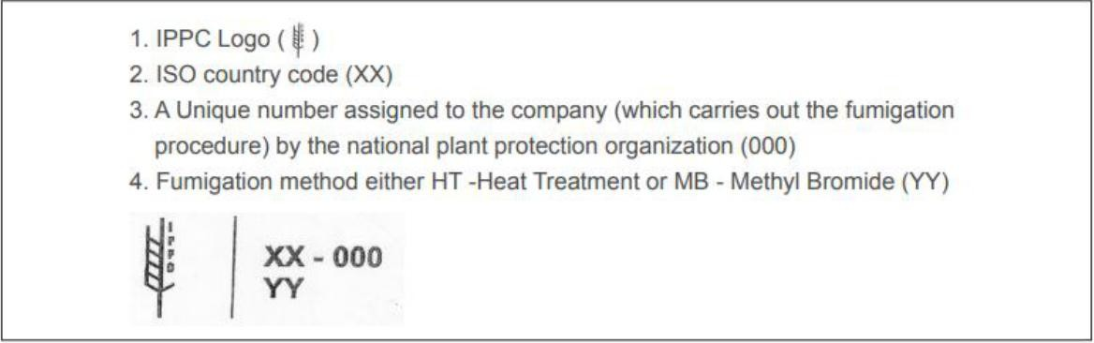
- To ensure that all the goods entering China has been fumigated via heat treatment (HT) or methyl bromide (MB), all the wooden packages must be marked with an IPPC logo as below that has been approved by the competent plant inspection and quarantine authorities:
For smooth customs clearance, exhibitors are advised to prepare a fumigation declaration (annex 6) printed on a paper with their company letterhead. Such declaration shall be attached to the original master air waybill (for air freight), or enclosed with the original bill of lading (for sea freight), or couriered to the official forwarders. All entering goods with wooden packages without acceptable fumigation logos or in no compliance with above requirements will either be destroyed right on the spot by the Chinese customs, or not be cleared and returned by force. As for entering goods with non-wooden packages, the consignor shall prepare a valid letter of certification or declaration (annex 5) stamped with the corporate seal of the goods owner, and couriered to the official forwarders together with the original air waybill (for air freight) or bill of lading (for sea freight).
Contact Information
Contact Person：Ms. Doris LIN Emai：transporter@cceecexpo.org Phone： 86-13958220178

Documents Required for Customs Clearance

Category |  | Documents required |  |  | Remarks
Wine & Spirits |  | - List of Overseas Exhibits  - One original ocean B/L or AWB  - Commercial invoice& Packing List  - Certificate of Origin  - Original wine label  - The third-party testing report self-testing qualification report | or | exhibitor’s
Prepackaged and beverage | foods | - List of Overseas Exhibits  - One original ocean B/L or AWB  - Commercial invoice& Packing List  - Certificate of Origin  - The third-party testing report self-testing qualification report | or | exhibitor’s
Plant-derived products |  | - List of Overseas Exhibits  - One original ocean B/L or AWB  - Commercial invoice& Packing List  - Certificate of Origin  - Chinese label  - Phytosanitary certificate of Country of Origin |  |  | Plant and Animal-derived products are only  allowed to be
Animal-derived products |  | - List of Overseas Exhibits  - One original ocean B/L or AWB  - Commercial invoice& Packing List  - Certificate of Origin  - Chinese label  - Veterinary certificate of Country of Origin |  |  | exhibited with the import admission by China Customs.
Cosmetics |  | - List of Overseas Exhibits  - One original ocean B/L or AWB  - Commercial invoice& Packing List  - Certificate of Origin  - Ingredients list  - Free Sale Certificate |  |  | The ingredients should checked by China Customs. | be
Electrical appliance |  | - List of Overseas Exhibits  - One original ocean B/L or AWB  - Commercial invoice& Packing List  - Certificate of Origin  - Product introduction/instruction
Others |  | - All advertising materials （ such as printed materials and souvenirs）and technical information materials in all media may be allowed for display or use at the CEEC Expo only after China Customs has examined  and approved them in the censorship clearance.

Reminders: China Customs reserves the right to adjust the statutory documents for customs clearance of exhibits that to be declared for the temporary entry and exit for the purpose of this exhibition.

Annex List

  - Plants and Animals as well as Their Products and Special Goods to be Approved of Entry

  - Quarantine Restriction List

  - Prohibition List of Inspection and Quarantine

  - The 4th China-CEEC Expo & International Consumer Goods Fair(2025) Overseas Exhibits List (Template)
  - Declaration of No-wood Packing Material

  - Template of Fumigation Declaration

  - Shipping Marks

Annex 1.

Plants and Animals as well as Their Products and Special Goods to be Approved of Entry

Animals and Animal Products | - Live animals and animal embryos, semen, fertilized eggs, breeding eggs, and other animal genetic materials;  - Imported animal serum products, vaccines, and biological products;  - Edible animal products: meat products (excluding cooked and cured meats), fresh egg products;  - Non-edible animal products: raw hides and skins (certain types), raw wool, bones, hooves, horns and their products, silkworm cocoons, meat meal, bone meal, meat and bone meal, fats, blood meal, blood, organic fertilizers and feed containing animal ingredients;  - Feed products: compound feed, frozen and chilled animal products for feed (including bait), aquatic products for feed (including bait), processed animal proteins and fats, pet food, and chew bones (excluding canned pet food).
Plants and Plant Products | - Seeds, seedlings, and their propagation materials;  - Fruits and vegetables: fresh fruits;  - Grains: wheat, corn, rice, barley, rye, oats, sorghum, rapeseed, and other miscellaneous grains;  - Legumes: soybeans, mung beans, peas, adzuki beans, broad beans, chickpeas, and other types of beans;  - Tubers: potatoes, cassava, sweet potatoes, and their processed products;  - Plant-based foods that pose a risk of spreading pests and diseases.

 | Genetically Modified Animal and Plant Products | Animal and plant products that fall within the scope of the genetically modified identification catalog must declare whether they are “genetically modified.” If they contain genetically modified components, a “Genetically Modified Organism (GMO) Biosafety Certificate” issued by the Ministry of Agriculture must be provided.
 | Special Goods | The importation of blood and other human tissues (including whole blood, plasma, serum, specific blood components, cells, cell lines, embryos, organs, tissues, bone marrow, secretions, excretions, etc.), pathogenic microorganisms (microorganisms that can invade the human body, causing infections or even infectious diseases, including viruses, bacteria, fungi, actinomycetes, rickettsiae, spirochetes, chlamydiae, mycoplasmas, prions, and other strains or samples, as well as parasites), and biological products (biological active preparations used in human medical fields, such as blood products, human proteins, vaccines, diagnostic reagents, cytokines, enzymes and their preparations, toxins, antigens, allergens, antibodies, antigen-antibody complexes, nucleic acids, etc.) must undergo approval and be issued an “Entry/Exit Special Items Health and Quarantine Approval Certificate” (except for those regulated as pharmaceuticals, veterinary drugs, or medical devices).
 |  | These items may only be imported after passing inspection and quarantine, and they must be subject to regulatory oversight upon entry.

Annex 2.
Inspection and Quarantine Restriction List
No. | Category | Conditions of Entry Inspection and Quarantine | Remarks
1 | Animal and Non- edible animal products | Animals, animal genetic material, non-food animal products, biological materials, animal-derived feeds:  - Apply for the Import Animal and Plant Quarantine Licence before entering the country, and the relevant inspection and quarantine requirements will be set out in the licence;  - Accompanied by official animal quarantine certificates of the exporting country or region. Among them, some low-risk biological materials and  low-risk non-food animal products are exempted from (1) (2) procedures and certificates (Remark 3 and Remark 10). | See the official website for details (the official website shall prevail and is not limited to the following):  - List of animals and their products prohibited from being imported from countries and regions where animal diseases are endemic http://dzs.customs.gov.cn/dzs/2746776/2753557/index.html  - List of countries or regions and species of aquatic animals that have been admitted http://dzs.customs.gov.cn/dzs/2747042/3995815/3995864/3996810/index.html  - List of risk levels and inspection and quarantine supervision measures for imported non-food animal products http://www.customs.gov.cn/customs/302249/302266/302267/6318313/index.html  - List of countries or regions and species of non-food animal products that have been admitted http://dzs.customs.gov.cn/dzs/2747042/3995816/fsydwcp/3996743/index1.html  - Exemption from verification of the exporting country or region of the list of official animal and plant quarantine certificates http://www.customs.gov.cn//dzs/2746776/4449008/index.html  - List of countries (regions) and products permitted to import feedstuffs (excluding feedstuffs of plant origin)

http://www.customs.gov.cn//dzs/2747042/3995816/dwyxsl/3996645/index.html

- Allowed to import feed additives and premixes country (region) and the list of products and registered enterprises http://dzs.customs.gov.cn/dzs/2747042/3995816/sltjj/index.html

- import and export of feed and feed additives risk level and inspection and quarantine supervision methods http://dzs.customs.gov.cn/dzs/2746776/2753474/index.html

- Announcement on Cancellation of Import Animal and Plant Quarantine Approval for Some Products (General Administration of Customs Announcement No. 51 of 2018)
http://www.customs.gov.cn//customs/302249/302266/302267/1889406/index.html

- ‘List of Imported Biological Materials Authorised for Animal and Plant Quarantine Approval’ ‘List of Risk Levels and Inspection and Quarantine Supervision Measures for Imported Biological Materials’ http://dzs.customs.gov.cn/dzs/2746776/2753479/index.html

- Announcement on Cancellation of Entry Quarantine Approval for Certain Animal and Plant Products (General Administration of Customs Announcement No. 77 of 2024)
http://www.customs.gov.cn//customs/302249/302266/302267/5960625/index.html

2 | Plants and products (plant propagating material, plant-derived feed, fresh fruits, fresh vegetables, plant-derived herbal medicines, plant-based seasonings, grains, oilseed oilseeds, unprocessed coffee beans, unprocessed cacao beans, new food ingredients of plant origin) | - Products should be granted quarantine access, the access list can refer to the remarks;  - need to apply for quarantine approval (refer to Annex 1) before entering the country for the ‘entry of animal and plant quarantine permit’;  - Need to be accompanied by the exporting country or region of the official health certificate or phytosanitary certificate should be accompanied by the certificate; | See the official website for details (the official website shall prevail and is not limited to the following):  - List of agricultural products and plant-derived medicinal materials permitted to be imported (Internet side: Animal and Plant Quarantine Department of the General Administration of Customs of the People's Republic of China - Animal and Plant Quarantine Requirements and Warning Information - List of Agricultural Products Permitted to be Imported / List of  Plant-Derived Medicinal Materials)  - List of registered enterprises allowed to import overseas (Internet: Animal and Plant Quarantine Department of the General Administration of Customs of the People's Republic of China - enterprise information - plants / plant products)

 |  |  | See the official website for details:
 |  |  | Catalogue of Food Products Exported to China from Countries or
 |  | 1.Should be granted national access, the access list can refer to the remarks; | Regions Meeting the Requirements for Assessment and  Examination and Having Traditional Trade (Aquatic Products, Dairy Products)
 |  |  | http://43.248.49.223/index.aspx
3 | Meat, bee products, casings, dairy products, aquatic products, bird's nests and other food of animal origin, Chinese herbal medicines of animal origin | - Included in the list of ‘Animals and plants, their products and special articles that need approval for entry’, apply for the ‘Entry Animal and Plant Quarantine Licence’ before entering the country;  - Official health certificates or animal quarantine certificates of the exporting country or region shall be attached; | List of Meat Products Exported to China from Countries or Regions Meeting the Requirements for Assessment and Examination and with Traditional Trade  List of Bee Products Exported to China from Countries or Regions Meeting the Requirements for Assessment and Screening and with Traditional Trade  List of Enteric Coating Products Exported to China from Countries  or Areas that Meet the Requirements for Assessment and Screening
 |  |  | and have Traditional Trade in Such Products
 |  | 4.Overseas production enterprises should be included in the List of Registered Overseas Production Enterprises of Imported Food. | List of Bird's Nest Products Exported to China from Countries or Regions Satisfying the Requirements for Assessment and Screening and with Traditional Trade  http://jckspj.customs.gov.cn/spj/xxfw39/cpjgzyxx/lsdwyxsp/nshlsd
 |  |  | wyxsppgsccx/index.html

4 | Infant formula milk powder | - It should be approved by the country, and the list of approved countries can be referred to in the notes;  - It should be accompanied by the official health certificate of the exporting country or region;  - It should obtain the product formula registration from the Food and Drug Administration;  - Overseas manufacturers should be included in the ‘Registered List of Overseas Manufacturers of Imported Foods’. | - ‘Catalogue of Food Products Exported to China from Countries or Regions that Meet the Requirements for Assessment and Review and Have Traditional Trade’ is available at  http://43.248.49.223/index.aspx  - ‘List of Registered Overseas Manufacturing Enterprises of Imported Food’ can be found in ‘China Customs Portal/Import and Export Food Safety Bureau/Information Service/Business Information’ under ‘Registered Overseas Manufacturing Enterprises of Imported Food’.  http://jckspj.customs.gov.cn/spj/xxfw39/jkspjwscqyzcmd/4650504  /index.html  - The registration information of infant formula milk powder product formula can be enquired by the State Administration of Market Supervision and Administration.

5 | Prepackaged food | For exhibition purposes: exempted from sampling and inspection, and exempted from affixing Chinese labels;  A small number of trial, tasting: depending on the audit and verification of the situation of taking samples (can be provided before the exhibition) inspection, and can be exempted from the affixing of Chinese labels; exempted from the registration of overseas production enterprises of imported food.  Sales purposes: the same requirements as general trade. | Certificate of Health Food Registration, Certificate of Health Food Record, Certificate of Registration of Formula Food for Special Medical Purposes can be enquired by the State Administration of Market Supervision.
6 | Cosmetics | Exhibition use: exempted from sampling and testing, and exempted from affixing Chinese labels;  A small amount of trial, distribution: depending on the audit and verification of the situation of taking samples (can be provided before the exhibition) inspection, and may be exempted from the affixing of Chinese labels.  Sales purposes: the same requirements as general trade. | The Certificate of Registration of Imported Special Cosmetics and the Certificate of Record of Imported Ordinary Cosmetics are available from the State General Administration of Pharmaceutical Supervision.

7 | Relevant imported products included in the scope of China's implementati on of licensing and mandatory implementati on of certification | Temporary entry: No restrictions. General trade use:  Subject to licensing/certification or exempt from licensing/certification vouchers. | See the official website for details (the official website shall prevail and is not limited to the following):  (1) Compulsory product certification catalogue https://www.samr.gov.cn/zw/zfxxgk/fdzdgknr/rzjgs/art/2023/art_0b
7 |  |  | 9e7843505b4336952d54859217fe2a.html  - Medical devices: https://www.samr.gov.cn/rzjgs/zcfg/art/2021/art_080c6dd958204f6 885410080853e78f1.html  - Special equipment: https://www.samr.gov.cn/zw/zfxxgk/fdzdgknr/fgs/art/2023/art_ad5e
7 |  |  | 293574484b48b45047ee0ede6099.html

8 | Products included in the scope of management of energy efficiency  labelling | Temporary entry: no restriction.  General trade use: energy efficiency labelling is required in accordance with national regulations. | See related official website: https://zfxxgk.ndrc.gov.cn/web/iteminfo.jsp?id=18488

9 | Risk level A and B special items | - Health quarantine approval is required for entry;  - The exhibition site must have relevant biosecurity control conditions. | See the official website for more details: Regulations on the Administration of Sanitary and Quarantine for Special Items at Entry and Exit Points  http://www.customs.gov.cn/customs/302249/302266/302267/23714
9 | Risk level A and B special items |  | 40/index.html
10 | Risk level C special items | Sanitary and quarantine approval is required for entry. | See the official website for more details: Regulations on the Administration of Sanitary and Quarantine for Special Items at Entry and Exit Points  http://www.customs.gov.cn/customs/302249/302266/302267/23714
10 | Risk level C special items | Sanitary and quarantine approval is required for entry. | 40/index.html

11 | Rough diamond | The original Kimberley Process International Certificate issued by the competent governmental authority of the country from which the rough diamonds were exported needs to be attached. | See official website for details:  - Joint Announcement of Six Kimberley Process Ministries http://m.mofcom.gov.cn/article/b/d/200304/20030400081833.shtml  - Administrative Regulations of the People's Republic of China on the Implementation of the Kimberley Process International Certification Scheme  https://www.gov.cn/gongbao/2024/issue_11566/202409/content_6973185
11 | Rough diamond |  | .html

12 | Hazardous chemicals | Hazardous chemicals listed in the Catalogue of Hazardous Chemicals (2015 Edition) shall comply with the provisions of the Announcement on Issues Relating to the Inspection and Supervision of Imported and Exported Hazardous Chemicals and Their Packaging (General Administration of Customs Announcement No. 129 of 2020), and shall be allowed to enter the country only after they have passed the customs inspection. | For details, see Catalogue of Hazardous Chemicals (2015 Edition) (Announcement No. 5 of 2015 by the General Administration of Safety Supervision, Ministry of Industry and Information Technology, Ministry of Public Security, Ministry of Environmental Protection, Ministry of Transport, Ministry of Agriculture, National Health and Family Planning Commission, General Administration of Quality Supervision, Inspection and Quarantine, Railway Bureau, and Civil Aviation Bureau) (see the official website of the Ministry of Emergency Management:  https://www.mem.gov.cn/gk/gwgg/xgxywj/wxhxp_228/201503/t201503 09_232632.shtml

Note: Temporary inbound and outbound materials for exhibition purposes are exempted from inspection in accordance with the law, unless otherwise provided for by laws and administrative regulations.

Annex 3.

Prohibition List of Inspection and Quarantine

No | Prohibited Items | Scope of Prohibition | Remarks
1 | Prohibited imports as stipulated in the Law of the People's Republic of China on Quarantine of Animals and Plants at the Entry and Exit of the People's Republic of China:  (a) Animal and plant pathogens (including strains, poisonous species, etc.), pests and other harmful organisms;  - Animals and plants, animal and plant products and other quarantine substances from countries and regions where animal and plant epidemics are prevalent;  - Animal carcasses;  - Soil. | Prohibition on Entry | See the official website for details:  - List of animals and their products prohibited from being imported from areas of countries where animal diseases are endemic http://dzs.customs.gov.cn/dzs/2746776/2753557/index.html  - List of Prohibited Imported Items for Phytosanitary Inspection in the People's Republic of China (Former Ministry of Agriculture Announcement No. 72 of 1997) http://dzs.customs.gov.cn/dzs/2746776/2753422/index.html

2 | - Food, edible agricultural products and feed from Fukushima, Gunma, Tochigi, Ibaraki, Miyagi, Niigata (except rice), Nagano, Saitama, Tokyo and Chiba Prefectures in Japan (the above origin and the scope of products involved are dynamically adjusted according to the risk assessment).  - Aquatic products (including edible aquatic animals) originating from Japan. | Prohibition on Entry | - Food, edible agricultural products and feed produced in other regions of Japan shall provide proof that the products originated from regions not specified in the Prohibited List; among them, vegetables and their products, milk and milk products, tea and products, fruits and products, and medicinal plant products shall also provide proof of passing the test for radioactive substances. Link to Niigata Prefecture Rice Import Notice: http://www.customs.gov.cn/customs/302249/302266/302267/59550 25/index.html  - General Administration of Customs Announcement No. 103 of 2023 on Total Suspension of Japanese Aquatic Products http://www.customs.gov.cn//customs/302249/2480148/5274475/ind ex.html
3 | Used electromechanical products and used clothing included in the catalogue of prohibited imports | Prohibition on Entry | See the official website for details:  - Matters Relating to the Adjustment of the Catalogue of Old Mechanical and Electrical Products Whose Importation is Prohibited, as Announced by the General Administration of Customs of the Ministry of Commerce, Announcement No. 106 of 2018 http://www.mofcom.gov.cn/zcfb/zgdwjjmywg/art/2019/art_048b8c6
3 |  | Prohibition on Entry | 68af64782b7151dc0bc0af05d.html  HS code for used clothing is 6309000000

Annex 4.
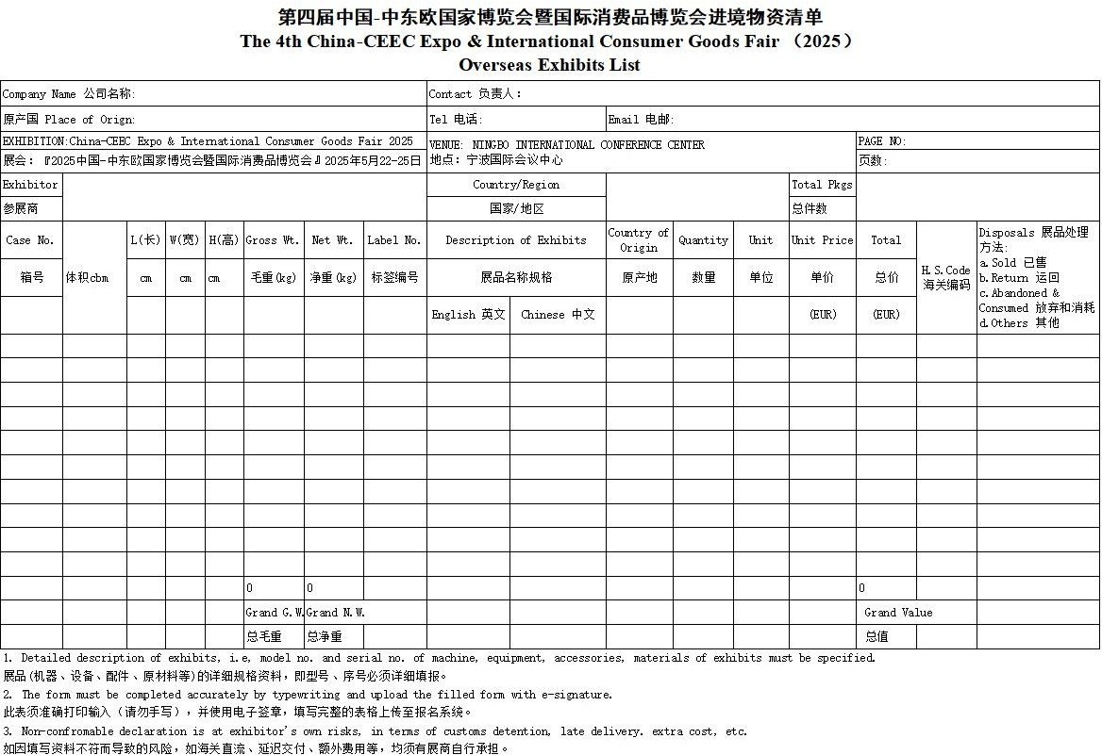

Declaration of No-wood Packing Material

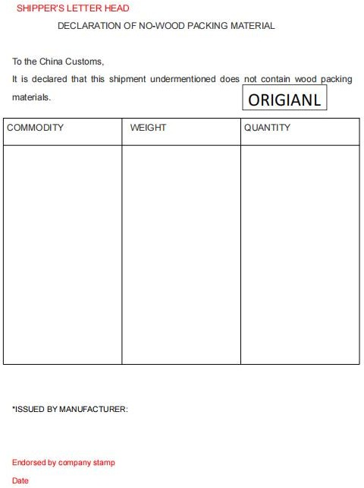

Fumigation Declaration

Name of the exhibitor (Company name):

Exhibits list Code:

Exhibition: 4th China-CEEC Expo & International Consumer Goods Fair

Our exhibition materials for the above event, comprising xxxxx (insert the total number of packages with wooden packing) cases, have been fumigated at xxxxxxx (name of origin port), carry the following IPPC logo and are marked with xxxxxxxx (state the exact Registered Fumigation Number i.e. XX-OOO YY).

Signature

Endorsed by company stamp Date

Shipping Marks

The 4th China-CEEC Expo & International Consumer Goods

Fair
Name of Exhibitor :
(Company Name)
Exhibits list Code:
Case Number :
Gross Weight/Net Weight :
Dimensions(Size):
Contact Person:

